Execrcise 1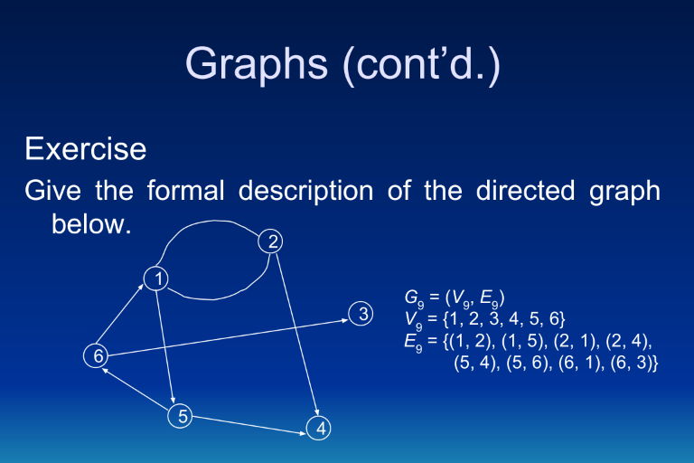
Indegree
1 is 2
2 is 1
3 is 1
4 is 2
5 is 1
6 is 1

Outdegree
1is 2
2 is 2
3 is 0
4 is 0
5 is 1
6 is 2

Exercise 2
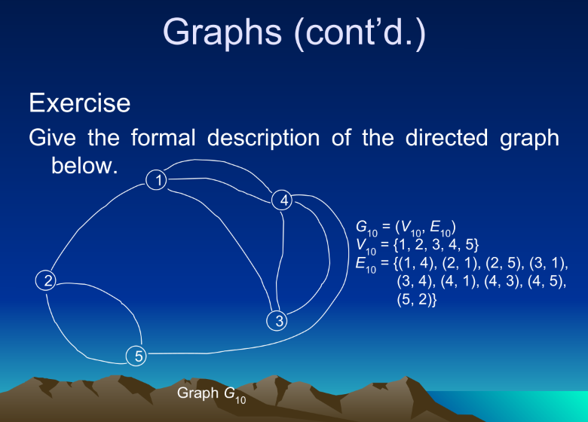
Indegree
1 is 3
2 is 1
3 is 1
4 is 2
5 is 2

Outdegree
1 is 1
2 is 2
3 is 2
4 is 3
5 is 1

Exercise 3
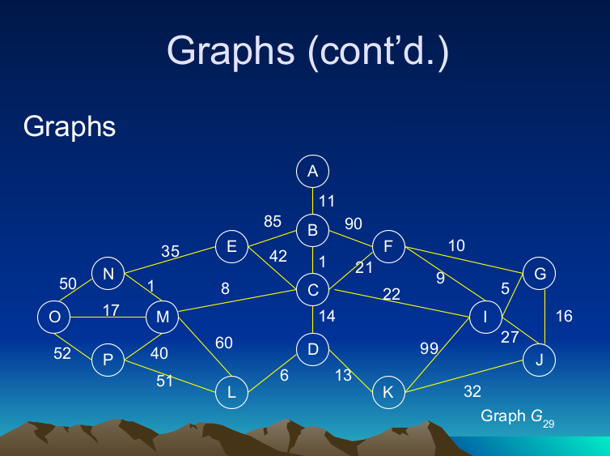

Kruskal
W(b,c)=1
W(n,m)=1
W(g,I)=5
W(d,l)=6
W(c,m)=8
W(f,I)=9
W(a,b)=11
W(d,k)=13
W(c,d)=14
W(g,j)=16
W(o,m)=17
W(c,f)=21
W(e,n)=35
W(m,p)=40
Total=197

Prim’s
W(a,b)=11
W(b,c)=1
W(c,m)=8
W(n,m)=1
W(c,d)=14
W(d,l)=6
W(d,k)=13
W(m,o)=17
W(c,f)=21
W(f,i)=9
W(I,g)=5
W(g,j)=15
W(e,n)=35
W(m,p)=40

